Shriners and the Seoul Shrine Club

The Seoul Shrine Club began in August of 1982 as the Dong Dae Mun Shrine Club, a voluntary and unincorporated association formed for social and charitable purposes in Seoul, Korea. The Club was formed under the auspices of the Dan Gun Oasis of Korea for the promotion of good fellowship among Nobles of the Ancient Arabic Order Nobles of the Mystic Shrine (A.A.O.N.M. S.) and to further the interests of said fraternity.
Today, the Seoul Shrine Club continues to conduct charitable fund raising activities primarily for the assistance of burned or crippled children. Any Noble in good standing in a legally constituted and chartered Temple of the Imperial Council, A.A.O.N.M.S. and residing in Korea can become a member of the Club. Presently, we have members who belong to various Temples in the United States and the Philippines.
The Seoul Shrine Club conducts regular business meetings the last Saturday of each month, at the designated locations on Yongsan, Seoul, Korea. We are very interested in increasing membership in the Club and urge all Masons to seriously consider this organization as part of their Masonic growth and education.
Contact our Secretary, Noble Robert E. Ring at this address: robert.e.ring8.ctr@mail.mil for more details.

BeginningsThe FezThe EmblemFun With a Purpose

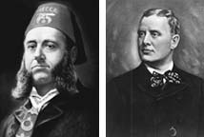

Walter Fleming and William Florence in 1872
In 1870 a group of Masons gathered frequently for lunch at the Knickerbocker Cottage on Sixth Avenue in New York City. At a special table on the second floor a particularly fun-loving group of men met regularly. Among the regulars were Walter M. Fleming, M.D. and William J. “Billy” Florence, an actor. The group frequently talked about starting a new fraternity for Masons – one centered on fun and fellowship, more than ritual. Fleming and Florence took this idea seriously enough to do something about it.

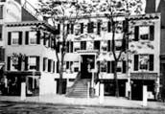

Knickerbocker Cottage on Sixth Avenue in Manhattan

Billy Florence had been on tour in France, and had been invited to a party given by an Arabian diplomat. The exotic style, flavors and music of the Arabian-themed party inspired him to suggest this as a theme for the new fraternity. Walter Fleming, a devoted fraternity brother, built on Fleming’s ideas and used his knowledge of fraternal ritual to transform the Arabian theme into the Ancient Arabic Order of the Nobles of the Mystic Shrine (A.A.O.N.M.S.).
With the help of the Knickerbocker Cottage regulars, Fleming drafted the ritual, designed the emblem and costumes, formulated a salutation and declared that members would wear the red fez.
The first meeting of Mecca Shriners, the first temple (chapter) established in the United States, was held September 26, 1872.
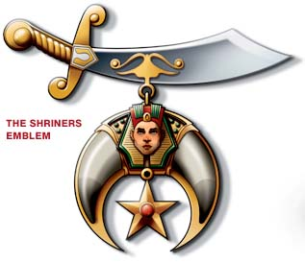

The emblem on the front of the fez, the crescent and scimitar, is an important part of the fraternity’s theme, and is representative of the characteristics embodied by the Shriners.
The scimitar stands for the backbone of the fraternity, its members.
The two claws are for the Shriners fraternity and its philanthropy.
The sphinx stands for the governing body of the Shriners.
The five-pointed star represents the thousands of children helped by the philanthropy each year.
The emblem also bears the phrase “Robur et Furor,” which means “Strength and Fury.”

Fun With a Purpose

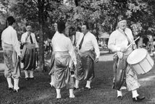

Shriner's band units and other clubs perform at parades, picnics and other events.
During the early part of the 20th century membership in Shriners International grew at a steady pace. By 1946, membership had jumped to 150,000 Nobles and another 250,000 had joined by 1958. In fact, Shriners International experienced one of its largest periods of growth in the years following World War II as returning soldiers looked for new ways to continue the camaraderie they had experienced with their fellow soldiers.

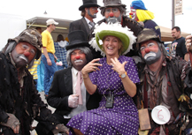

The Shrine Circus has been raising money and entertaining families for generations.
As the number of temples and nobles grew, so too did the hospitals. By 1958 the hospitals’ endowment was valued at $125 million and growing. The nobles were proving themselves to be excellent fundraisers. The Shrine Circus, founded in 1906 for fun and entertainment, began to play a role as a significant fundraiser in support of the hospitals.
Today, there are nearly 200 temples across North America, South America, Europe and Southeast Asia. In addition to the Shrine Circus, temples hold events throughout the year ranging from fish fries to concerts, car shows to fishing tournaments. It is fun with a purpose – supporting the important mission of Shriners Hospitals for Children®.

Masons and Shriners
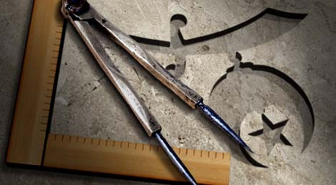

All Shriners are Masons, but not all Masons are Shriners.
Shriners International is a spin-off from Freemasonry, the oldest, largest and most widely known fraternity in the world. Freemasonry dates back hundreds of years to when stonemasons and other craftsmen gathered after work in shelter houses, or lodges. Over time, the members organized into Masonic guilds and the tools of their trade – the square and compass – became the symbol of their brotherhood.
Over time, Masonry evolved into an organization that began to accept members who were not craftsmen. Today, Masonry is built upon a foundation of improving character and strengthening communities, though the square and compass are still the symbols of the fraternal brotherhood.
When Shriners International was first founded in 1872, the organization built on the principles that guided Freemasonry, while adding an element of fun and ultimately, philanthropy, that set Shriners International apart. The two organizations are also structured similarly:
- Shriners have temples; Masons have a Blue Lodge or Craft Lodge
- Members of the Masonic lodges are required to learn about their fraternity and earn a series of Masonic degrees.
- When a member has completed the third and final degree he becomes a Master Mason and is then eligible to become a Shriner.
- Additional courses of Masonic study are available – these are known as the Scottish Rite and the York Rite.
To learn more about how to become a Mason and a Shriner visit www.beashrinernow.com.

